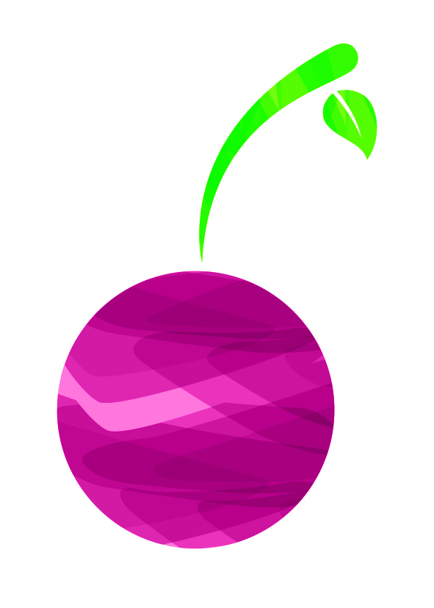
Programme Advert Application
BLACK CHERRY FAIR
Saturday 8th July, 2023
31, Grove Road, Chertsey, Surrey. KT16 9DN
07790 604016
admin@blackcherryfair.com
www.blackcherryfair.com

NAME:
BUSINESS NAME:

ADDRESS
POSTCODE

TELEPHONE
DAY/EVE
MOBILE

E-MAIL
ADVERT  (please tick) | Inside front/back cover (colour) £150
Full page colour £140
Full page B&W £130
 | Half page £85
 | Quarter page £50
Banner space around main arena £50
With 1 metre banner made by sign-media £120 for more than 1 banner please contact us for price
 | Other advertising :-
I ENCLOSE CHEQUE/CASH FOR £
Bacs payment to: Black Cherry Fair: sort code: 20:90:56 account number: 10218782
Cheques made payable to Rotary Club of Chertsey (Black Cherry fair) ltd. Post to: Black Cherry Fair, 31 Grove Rd, Chertsey, Surrey. KT16 9DN
Please TICK one of the following sentences:

I would like my advert to remain the same as last year

I would like to be contacted with regard to text and layout of my advert

PLEASE RETURN FORM BY JUNE 9th, 2023
DEADLINE FOR COPY JUNE 16th, 2023
Once your application has been received we will send you confirmation of reserved space and contact you
with regard to text and layout where necessary.

Organised through the Rotary Club of Chertsey

